**SYNOPSIS**

**Report on**

**E- COMMERSE WEBSITE CLONE**

**by**

Name: Sushant Chaudhary, Roll- 2200290140155

Name: Sushant Singh Negi, Roll- 2200290140156

**Session:2023-2024 (III Semester)**

Under the supervision of

**Prof. (Dr.) Akash Rajak**

### KIET Group of Institutions, Delhi-NCR, Ghaziabad



### Department Of Computer Applications

**KIET GROUP OF INSTITUTIONS, DELHI-NCR, GHAZIABAD-201206**

(2023 - 2024)

**ABSTRACT**

An e-commerce website clone allows customers to browse and purchase products and services online. The website allows users to register accounts and create login credentials to access their account pages. From their accounts, customers can view product listings organized into categories on the homepage. They can click through to detailed product pages with images, descriptions, specifications and reviews. From the product pages, customers can select options and quantities and add products to their shopping cart. Once they have added all desired products, they can proceed to checkout by clicking the shopping cart icon. At checkout, customers fill in their shipping address and payment details to place an order. On the admin side, database admins can manage products by performing actions like adding new products, editing existing product details and images, and deleting products from the catalog. Finally, admins can manage user accounts by blocking, suspending or banning users when required. The clone aims to replicate the core features of an e-commerce store in a simple and user-friendly manner to facilitate online shopping.

In summary, the main focus will be on building all the necessary features required for an e-commerce store like Amazon while maintaining a user-friendly interface and smooth user experience. Security and performance optimization will also be taken into consideration.

**TABLE OF CONTENTS**

Page Number

Chapter 1 - Introduction  04 - 07

1.1 Project description  04

1.2 Project Scope  04

1.3 Hardware / Software used in Project  06

Chapter 2 Feasibility Study  08

Chapter 3 Database Design  09 - 10

3.1 E-R Diagram 09

3.2 Flow Chart  09

3.3 Use Case Diagram 10

Chapter 4 Coding

            Module wise code

Chapter 5 Proposed Time Duration

References

**INTRODUCTION**

**1.1 Project Description**

An E-commerce website is an online store where customers can browse and purchase products and services. This project aims to develop a fully functional E-commerce website for selling products online.

The key features of the E-commerce website are:

* The website will have categorized listings of various products for sale. Customers can browse products by category, search for specific products, and view product details pages.
* Customers can add products to their shopping cart and proceed to checkout. The cart will keep track of the items, quantities, and total price.
* Customers can proceed to checkout where they enter their shipping and billing information. Various payment options like credit card, debit card, PayPal, etc. will be integrated to allow customers to make secure payments.
* Registered customers will be able to create accounts, maintain their profile information, view order history and track orders.
* Admin users will have access to an admin panel where they can manage products, categories, orders, users and configure website settings.
* The website will integrate with various payment gateways, shipping carriers, email service providers, etc. to provide a seamless customer experience.

In summary, the E-commerce website will provide all the essential features to operate an effective online store where customers can browse, buy and sell products with ease. The website will be developed to be scalable, secure and optimized for both desktop and mobile devices.

**1.2 Project Scope**

Here is the project scope for an e-commerce website clone:

• The scope of the project will be to build a fully functional e-commerce website with features similar to Amazon.

• The website will allow customers to browse products, add products to cart, checkout and make payments.

• The main focus will be on the frontend - building an easy-to-use and responsive customer-facing website.

• The admin interface will allow managing products, orders, customers and other site settings.

• The following features will be in scope:

* Product catalog management
* Shopping cart
* Order management
* User authentication and authorization
* Search and filter products
* Wishlist
* Reviews and ratings

• The following features will be out of scope for the initial version:

* Recommendation engine
* Loyalty programs
* Advanced analytics and business intelligence
* Mobile app
* Drop shipping or order fulfillment
* Multi-vendor support

• Security, performance and scalability will be considered but not optimized to the level of Amazon. The initial focus will be on building a minimum viable product.

• The website will be developed using React JS, Node JS, and Mongo-DB.

In summary, the scope of the project is to build the basic yet essential features required for an e-commerce store, with an emphasis on the customer-facing website while keeping security, performance and scalability in mind to a reasonable extent.

**1.3 Hardware / Software used in Project**

Here are the hardware and software that can be used for an e-commerce website clone project:

Hardware:

* Web server: A high-performance web server will be required to handle the traffic and load of an e-commerce website. Options include AWS EC2 instances, Google Cloud Compute Engine, or a dedicated server.
* Database server: A database server will be needed to store product data, order details, user information, and more. Options include AWS RDS, Google Cloud SQL, or a self-hosted SQL database server.
* Load balancer (optional): A load balancer can be used to distribute traffic across multiple web and database servers for high availability and scalability.

Software:

* Web server: Node JS HTTP Server
* Programming languages: React JS, JavaScript, HTML, CSS.
* Database: Mongo-DB

Other tools:

* Text editor: VS Code.
* Browser dev tools: For testing and debugging.
* Version control: Git.

In summary, to develop an e-commerce website clone, you'll need a combination of hardware resources like web and database servers, and software like programming languages, frameworks, libraries and tools. The specific stack depends on your preferences and requirements.

The important thing is to choose technologies that you are comfortable with while keeping performance, scalability and security in mind.

**FEASIBILITY STUDY**

Building an e-commerce website clone requires careful consideration of technical, financial and operational feasibility.

Technically, the project is feasible as it involves common technologies like React JS, Node JS, Express JS and a distributed database. However, custom development requires expertise in these technologies and associated frameworks.

Financially, the costs primarily involve website development and maintenance, product catalog management, payment processing and marketing. Initial development costs depend on the features, scale and customization required. Recurring costs include server hosting, transaction fees, support personnel and marketing spend. Revenue sources include product sales, subscription plans, advertising and affiliate commissions.

Operationally, the key tasks involve product sourcing and management. Product data needs to be maintained and kept up-to-date. Orders must be fulfilled accurately and on time to ensure customer satisfaction. Customer queries need to be addressed promptly through email, live chat and call centers. Payment gateways and shopping cart software need to be integrated securely. Legal and regulatory compliance in areas like taxation and data protection is essential.

In summary, while an e-commerce website clone is technically feasible using existing technologies, its financial viability and operational sustainability depend on factors like the product catalog, target market, competition, funding availability, internal resources and management capabilities. A detailed feasibility study covering all technical, financial and operational aspects can determine if the project is worthwhile and identify potential risks and mitigation strategies. Pilot testing with a small set of products, customers and transactions can also provide valuable insights before a full-scale launch.

**DATABASE DESIGN**

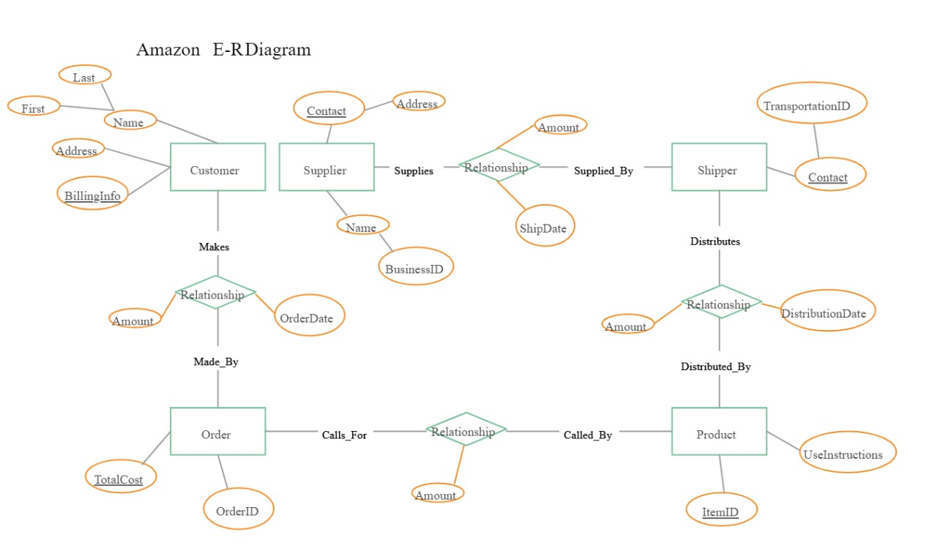**3.1 E-R Diagram:**

**3.2 Data Flow Diagram**

**3.3 Use Case Diagram**

A use case diagram is a type of diagram in the Unified Modelling Language (UML) that is used to visualize and describe the functional requirements of a system from an external user's perspective. It provides a high-level view of how users interact with a system and the various functionalities or use cases the system offers in response to those interactions.

Use case diagrams are particularly useful for:

* Communicating the system's functionality and behaviour to stakeholders in a visual and understandable way.
* Capturing and documenting high-level user requirements.
* Identifying system boundaries and external interactions.
* modelling how different use cases relate to each other.

They are a valuable tool in the early stages of software development for understanding and discussing the functional aspects of a system before diving into more detailed design and implementation phases.

